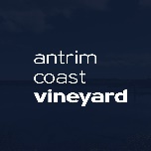
Antrim Coast Vineyard Essentials Care Bundle
Contact Andrea Howard: 07512 422355
Name of Organisation |  | Church Info
Name of Referrer

Referrer
Contact number
Details of
Client

Care Bundle  required |  | E.g. New Mum
Extra Items
required
Date Received
Date Delivered

  - A Church making room for another
  - www.antrimcoastvineyard.org

